The brief provides a lot of elements for understanding the “one touch” game type like:

* multiplayer/Co-op sharing the same screen by turns;
* to be simple, easy to learn, captivating, addictive and competitive with yourself to beat the score or to do better;
* to be offered to a range type of peoples and ages.

Some games that could fit the brief are :

1. Stack ( <https://www.youtube.com/watch?v=fDAOtiiGBFY>). This is one type of game that use one tap. A platform comes from a way and when you tap its stop. I order to reach high scores you need to BALANCE the platforms.
2. 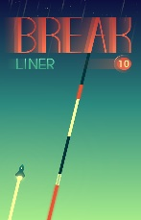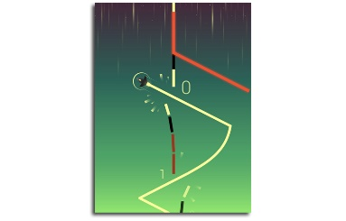Break Liner ( <https://www.youtube.com/watch?v=_omlO5V3NLs> ) . This game use a ship that is floating and when the player tap it changes direction to the opposite part of the screen.